**Writing in APA style**

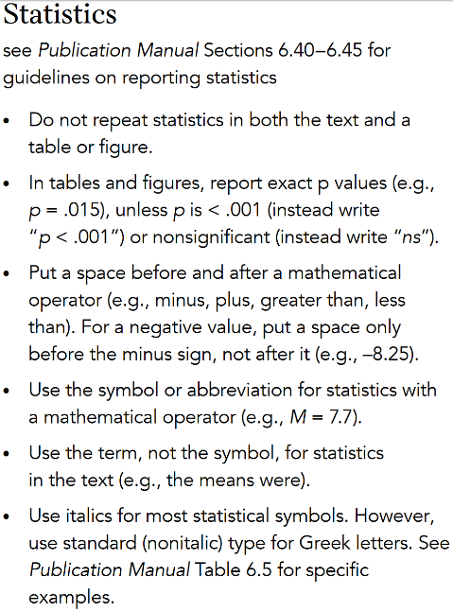 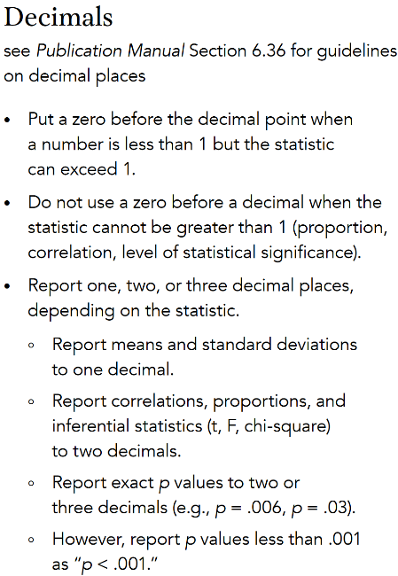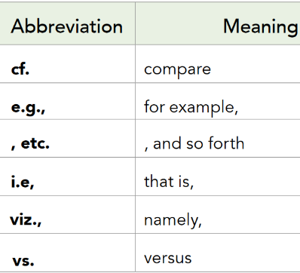

**Helpful phrases**

To explain in a different way: That is, In other words,

To illustrate: Specifically, For example, As one example, In particular,

To emphasize a point/finding: Interestingly, It is interesting that… Surprisingly,It is surprising that … Importantly, It is important that…

To present your own idea/argument: It seems plausible that… It seems reasonable that… It seems logical that… It could be argued that…

To show cause/consequence: As such, Consequently, Therefore, Thus, To show contrast .. By contrast, Conversely, However, Although, Nevertheless, Nonetheless, _____ notwithstanding, On the one hand, ...On the other hand,

To show additional examples: Similarly, In a similar manner, In addition, Additionally, Moreover, Furthermore, Another study …

To summarize/conclude: In short, In sum, Overall, In general, Taken together, these findings…

To show a sequence of events: First, Next, Then, Finally,

To relate to hypotheses: Consistent with… Contrary to… As predicted, As expected, In agreement with… In accordance with… Congruent with …

Especially for discussion phrases, look at <https://apastyle.apa.org/instructional-aids/discussion-phrases-guide.pdf>

**General remarks** on the **Discussion section** to make it a *clear, concise and interesting to read* section at the end:

Write in present tense.

*Avoid exaggeration*. Speculation is fine as long as you acknowledge that you're speculating and you don't stray too far from your data. That includes avoiding language that implies causality when your study can only make relational conclusions (use *'correlated with*', *'was associated with'* and *'related to’*).

Try to find a balance where you set a tone that indeed *celebrates interesting findings* without too many leaps, while at the same time reporting limitations without being unnecessarily negative. instead of simply summarizing your data and suggesting a few obvious follow-up studies

Think about *presenting your data in a novel way*, showing how the work might *resolve an existing controversy in the literature* or explaining how it *connects to an entirely different literature*.

**Discussion** (one subsection for each content paragraph?):

Summary of key findings: What do our empirical and statistical findings mean (e.g. in terms of our *research hypotheses*)?

Comparison to previous studies: How do they relate to the *original study* (what fits and where are differences)? How well do they match with the *background of the original study* (replication of Ren et al.; ATOM)?

Theoretical/Practical implications: What might be possible *implications* of our findings beyond the original study (regarding cases of application of the matter of our investigations, explain why others should care about your findings (🡪suppositional reasoning but no exaggeration))? Do they *resolve an existing controversy* in the literature? Do they *relate to* some other phenomenon/entirely *different literature*?

Limitations of the study: address possible *limitations of our study* after having discussed the positive results (humility section)

Outlook/Directions for future research: *suggestions for follow-up studies* (but not on the expense of the present study)

Conclusion: Conclude the general discussion with a strong paragraph stating the *main point or points again*, in somewhat different terms -if possible- than used before.